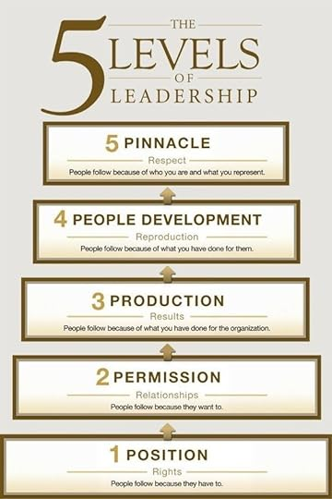

Culture and the 5 Levels of Leadership.

John Maxwell is considered THE Leadership Thought Leader in the world today. He has written close to 100 books on leadership and sold over 30M copies. One of his most popular books is the 5 Levels of Leadership. It is his most requested speaking topic.

It’s impossible to talk about leadership without understanding the role that Culture plays in Leadership. You see, Leaders may think they lead a company. Large or small, you do not lead things, you lead people. The essence of Culture is people. Your people and how they behave. There is no strategy in the world that can overcome the behavior of your people. The challenge there is that your looking for the discretionary effort of your people.

The first level of leadership is the Position level. Most organizations lead their people from the first level of leadership. At this level, people HAVE to follow you because of the Position you hold and the power you have over your people. In other words, they have no choice but to follow you. That power comes in the ability to influence people with threats, salary reductions and/or write ups. Positional leaders lead through intimidation. The result is you get your people’s minimum effort. They are thinking…”What’s the least I can do before they fire me?”

In the 5 Levels of Leadership, the next level, is Permission. And at this level your people give you Permission to lead them. In other words, they WANT to follow you. They have the choice to follow you. They are willing to give you their Discretionary Effort which goes way beyond the minimum we see at Level 1 Position.

The Permission level is all based on your ability to build relationships with the people you hope will become followers that willingly give you their discretionary effort. Until you reach the Permission level you will never progress to the next 3 levels.

